Minutes of the Committee Meeting 10th October 2016

Present:
Nathan Scott Chairman
Andy Reid Secretary
Chris Green Treasurer
Dave Debnam Vice President
Lorraine Webb Ladies Captain
Andy Ward
Miriam Linforth
Helen Morris
Thom Darby
Zena Ellis

1 Chairman’s Comments
None available

2 Apologies
Apologies were received from Chris Green, Lorraine Webb and Paul Davies has resigned.

3 Previous Minutes
The minutes for September were accepted.

4 Matters Arising
Tony is free to organise a trip to an Athletics Meeting next year from his suggestion last month.

5 Secretary Report
Correspondence received:
The Gloucester Marathon on 5/2/17
7 for 7 in 7 event
XC league entry registration fee was due and paid.
Winter coaching development.
Leighton Fun Runners Halloween event Oct 25th at 7.15pm from the Globe on the canal.
Foodbank Fun Run
Team Beds Luton club forum at Beadlow
Toe Tag 2 I.D. to attach to shoe £2.99 each
England Athletics runtogether roadshow 9.11.16
3 Counties CC league meeting minutes
3 A’s committee meeting
Paul Davies resignation Email on 1/10/16

6 Treasurer’s Report
CG reports
Bank £6192
Charity £1596
Race
Sponsorship £1394
Costs £1459
Entries since 40 people x £12 = £480

Running Report
Running Report by Lorraine Webb & Paul Davies for September 2016
Are we really in September already ? This month saw our Striders out in force taking part in the usual Saturday morning parkruns, the St Albans Stampede, the launch of the Canal and River Trust races and the Great North Run to name but a few. We hope many of you have now signed up for our own race and if you haven’t, what are you waiting for ?
Can we please ask that you check your parkrun profile is showing Stopsley Striders as your running club as that will help us find your run & time a lot quicker and ensure we don’t miss you off the running reports.
As you will have noticed, the darker nights are already creeping in and unfortunately we bid farewell to the fields for our Thursday speedwork sessions for the time being. As the nights draw in, please remember to stay safe and be seen. As some of you will remember from last year, there are all sorts of flashing gadgets available on the market and don’t forget our very own club branded hi-viz training t-shirts are available to buy – check out the website if you’re interested.

Weekend of 3rd & 4th September
Luton’s parkrun saw our Striders taking both the men & ladies first places. Rob Barnes finished in 18:29 & Christina Green in 22:30. Also running were Pete Croall (19:10), Thom Darby (22:05), Nick Sandle (23:04), Hannah Fothergill (24:02), Sonia Blackett (27:44), Kat Tuloo (29:09 parkrun PB), Maria Petts (32:01), Karen Bull (34:22 parkrun PB), Lisa French (35:21), Janine Blackett (35:54), Penny Kilbey (36:02), Tommy Murphy (36:06), Lu Philpott (37:43 parkrun PB), Charlotte Williams (43:09) and Lee Bearley (52:06).

parkrun tourists:
- Stevenage – Kim Caddy (27:53) & Terry Willis (28:08).
- Linford Wood – Philip Davies (21:19), Stewart Read (24:47) & Liz Davies (26:00).
- Ballincollig – Alan Barry 20:19.

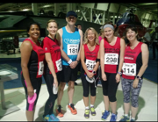
Kulwinder Assra (60:56 PB), Carly Eaves (58:38), Mark Layzell (67:31), Valerie Dawson (58:36), Siobhan Jenkins (63:35) & Amanda Rankin (65:33) ran the Spitfire 10K.

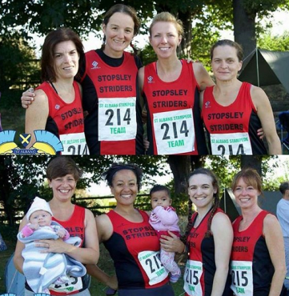
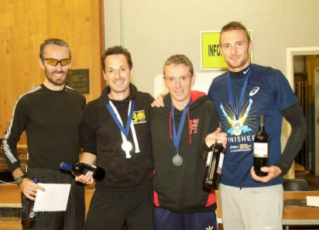
The rather wet & grey St Albans Stampede saw our Club represented
by 3 Teams: the Men’s Team comprising of Paul Davies, Gez Fallon,
Mark Sains & Nathan Scott came 3rd overall, completing 26 laps
(104 miles) in the 12 hour time allocation.
Team “Round and round we go” aka Sarah Cashin, Christine Lathwell,
Liz Rollinson & Linda Scanlan completed 23 laps (92 miles) and
Team “Stopsley Striders Sisters With Blisters” aka Ellie Ballinger,
Miriam Linforth, Gerri Tate & Vanessa Thompson completed
19 laps (76 miles).

Tony Riley took part in the Kew/Richmond 10k and finished the run along the Thames in 54:40.
Martin Smith & Danny Kelly fancied the challenge of self-orienteering and Martin navigated himself around the Dunstable Downs 20mile course in 4:06:00 and Danny decided his map reading skills were up to the marathon course and finished in 4:10:00 – I’m pleased to report, not only did neither of them get lost over the Downs, Danny also gained himself a PB and finished in 5th place !

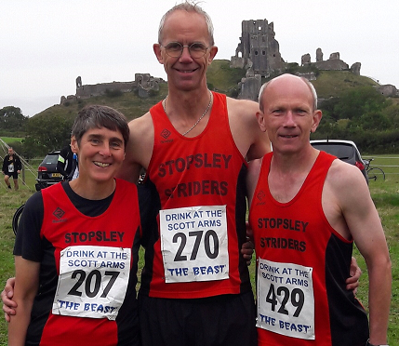

The Beast Half Marathon saw John Chapman (1:48:58),
Paul Keech (1:55:38) & Hilary Adams (2:15:36)
representing Striders.

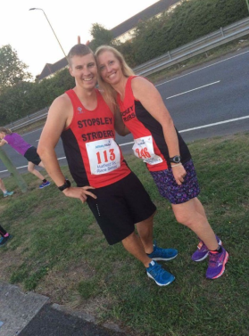
7th, 10th & 11th September

A very muggy mid-week race saw Ben Bodsworth & Lorraine Webb take part in the
first race of the Hatfield 5k Race Series. Ben finished in 19:52 and Lorraine in 25:29.

A very special Luton purple parkrun in aid of the Willow Foundation saw 23 Striders taking part with Rob Barnes taking 1st overall place. Rob was followed by Pete Croall (18:46), John Chapman (20:04), Philip Davies (21:26), Thom Darby (21:55), Lee Bearley (22:13), Dave Thompson (23:59 parkrun PB), Simon Cain (27:17), Tom Willis (27:18), Lorraine Webb was our first female Strider home in (27:36), Stewart Read (28:57), Liz Davies (28:59), Kulwinder Assra (29:07), Nikki Cox (30:04), Judy Reid (30:06 parkrun PB), David “Birthday Boy” Brown (31:15), Alison Howe (32:24 parkrun PB), Rachel Burns (33:12 parkrun PB), Karen Bull (34:31), Penny Kilbey (34:55 parkrun PB), Pauline Moran (36:45 parkrun PB), Bimla Assra (41:46), Charlotte Williams (42:25) and Terry Willis (51:40).
parkrun tourists:
- Hackney Marshes - Mark Layzell (30:12).
- Roundhay – Kim Caddy (29:03).
Gary Fowler took part in the Nocturne 10k au Port and finished the course in 48:42 which gave him a MV55 PB – well done Gary – bet it was almost as warm as here ;-)

The amazing Great North Run saw Striders being represented by Andy Durrant (1:57:50), Valerie Dawson (2:19:23) & Amanda Rankin (2:28:29).

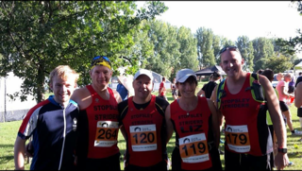

Tom Hull (1:31:36 PB), Stewart Read (2:04:54), Liz Davies (2:08:57), Martin Smith (2:16:00), & Terry Willis (2:28:09) took part in the inaugural Two Arms on Two Legs Half Marathon organised by the Canal & River Trust.

17th & 18th September
A diary clash at Wardown meant there was no parkrun this week which resulted in our Striders travelling to more parkrun locations than usual.

- Ally Pally – Mark Layzell (33:05).
- Aldenham – Maria Petts (29:36).
- Aylesbury – Lee Bearley (21:56).
- Northampton – Paul Davies (19:29) & Lorraine Webb (25:07).
- Rushmere – Kate Neale (33:46).
- St Albans – Karl Tull (18:28).
- Stevenage – Philip Davies (20:59), Stewart Read (24:39), Liz Davies (25:16), Kim Caddy (28:01) & David Brown (30:25).

On Sunday, Tom Hull took part in the St Paul’s Walden Amaudo 10k and finished in a PB time of 39:16.
Derek Christopher took part in his first Aquathlon, finishing the Duck ‘n’ Dash – well done Derek !
Daniel Mann ran the Leighton 10 mile race and finished in a PB time of 1:13:50. Dan was closely followed by Lewis May who also ran a PB of 1:16:26. Well done guys ! Great stuff !

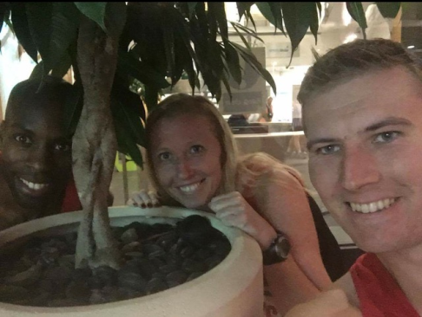
21st, 24th & 25th September
Another muggy evening saw Ben Bodsworth & Lorraine Webb
competing in the 2nd race of the Hatfield 5k Series. Joining them
was Karl Tull who achieved his goal of a sub 18, finishing in a PB time of 17:43.
Ben, not wanting to miss his chance of also securing a PB, completed the course
in 19:31 beating his previous PB by a second - you don’t get much closer than that !!
Lorraine finished in a slow 24:51 in comparison and the less said about her
forgetting to pick up her chip and hounding the poor Race Director the better.
Jokes aside, well done everyone !

24th & 25th September
Luton’s parkrun saw Robert Barnes crossing the finish line in 1st place overall in a time of 18:14. Rob was followed by John Chapman (19:31), Pat Blessing (21:04), Linda Scanlan was our first female Strider home in (21:39), Lee Bearley (22:05), Philip Davies (22:22), Christina Green (25:19), Iain Mose (25:24 parkrun PB), Gordon McCulloch (26:48), Liz Davies (27:03), Brian Davies (27:22), Kat Tuloo (28:48 parkrun PB), Dave Thompson (29:34), Amrik Singh (30:13 parkrun pb), Liz Evans celebrating her 50th parkrun (31:00), Maria Petts (31:27), Lisa French (31:28) Donna Wiggett (32:22), Zena Ellis (33:17), Kim Caddy (33:18), Meriel Ascott (33:38), Alison Howe (36:12), Tommy Murphy (37:27), Pauline Moran (38:19), Claire Bates (40:48 parkrun PB), Cindy Guerin (46:41) and Lu Philpott (48:31).
parkrun tourists:
- Riddlestown – Mark Layzell (31:19).

Our Striders were well represented at the Hitchin 5k with Andy Durrant (22:58), Hannah Fothergill (23:25 PB), Terry Willis (28:29), Kate Neale (29:40), Mark Layzell (30:10), Amanda Rankin (30:55), Christine Hunter (32:28), Lu Philpott (37:29 PB) all crossing the finishing line.

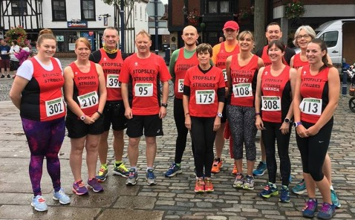

Martin Fallon finished the Dublin Half Marathon course in a time of 1:40:44.

Dan Lewis secured a PB of 4:12:48 in the Berlin Marathon – welcome to the “Want to get Sub-4 Club” ☺

Alan Barry completed the Ealing Half earning himself a PB of 1:28:43.

Mark Sains wearing his Striders’ Vest with pride finished the Barnstaple Marathon in 3rd place overall in another sub-3 time of 2:50:26. Bit like buses eh Mark ;-)

Gez Fallon finished the MK Half Marathon in a time of 1:26:54.

As I finish this report, I have just 3 ( !! ) final things to say:
- Have you signed up to our race yet ? If not, please, please, please ( don’t make me beg ) do so…
- The sign-up sheet for the Three Counties Cross Country Championships has been out at Club for the last few weeks.
Is your name down ? Names have to be submitted to the organisers by 9th October, so if for any reason you’ve forgotten or not been able to get to Club, let Paul or I know by the 8th October and we will include you. Don’t forget, at this stage, it’s just so we can get you a participant number as we cannot guarantee that you’ll be able to enter any of the races on the day. Apart from the great team camaraderie, the pure childish fun associated with running through puddles and the potential to roll around in the mud ( whatever takes your fancy ), it’s worth taking part just for the cake - isn’t that right Kelvin…
- If you want your race result mentioned in the Running Report, please remember to complete the race sheet which is available on all Club Nights. If you know you won’t make it to Club in the same month you raced, please e-mail with the details.


YOUR CAPTAINS WANT YOU
PSST: THINK ABOUT THE CAKE……..

Strider of the Month Trophies
Karl Tull for his under 17min 5K!

Striders Race
There are now 117 entrants.
It has been decided that there will not be goody bags now to reduce costs.
30 marshals shall be provided by the Charity, with extra bodys provided by the scouts.
We hope to get a supply of banana’s and water.

AGM
Will be held on the 17th November but we still need to find a venue.
There is one Charity nomination so far, the Willow foundation.
Committee members willing to stand for the new committee are Dave D., Andy R., Helen, Zena, Miriam, Andy W, Thom, Nathan.
We will need a Chairman, Mens captain, and possibly a Ladys captain.
To promote need for vacancys to be filled.

Beginners course survey
Nathan will circulate the results

Suggestions
Dave Thompson asked if the club colours could be changed.

A.O.B.
Lorraine says the old kit needs to be disposed of. Decision taken to take it to the AGM for sale.
AR none
Helen none
Zena asked if she can get people doing work experience at work to design it. Agreed
Miriam none
Andy W none
Thom Matt organised the quiz well. To be used again next year.
Nathan none

Next Meeting to be held in the Barrels on 7th November 2016

